**Data warehouse and Business Intelligence**

**Motivation**

To develop an understanding of creating data warehouse and automating operations and data population using Python scripts

**TASK 1:**

* **Create Northwind data warehouse in sql server .**
* **Follow the structure given below in screenshot.**

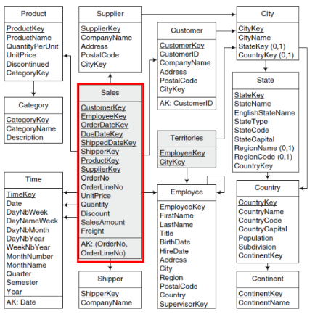

**TASK 2: Referential Integrity**

* Check referential integrity constraints in above schema
* Check all relationships

**TASK 3: Populate the schema**

* For each table enter data in it using visual method or using queries
* If using queries , use faker module of python

**TASK 3: Write SQL queries for the following basic statements**

1. Select monthly sales by customer state compared to those of the previous year
2. Monthly sales growth per product, that is, total sales per product compared to those of the previous month
3. List the top three best-selling employees